**Write a program to draw a circle in Frame with following Specification (x, y, r) = (100, 50, 50)**

import java.awt.*;

import java.applet.*;

import java.awt.event.*;

public class Circle extends Frame{

Circle(){

setBackground(Color.black);

setForeground(Color.cyan);

addWindowListener(new WindowAdapter(){

public void windowClosing(WindowEvent we){

System.exit(0);

}

});

}

public void paint(Graphics g){

g.drawOval(100, 50, 50, 50);

// g.fillRoundRect(120, 120, 60, 60, 60, 60);

}

public static void main(String arg[]){

Circle obj = new Circle();

obj.setTitle("Circle");

obj.setSize(400, 300);

obj.setVisible(true);

}

}

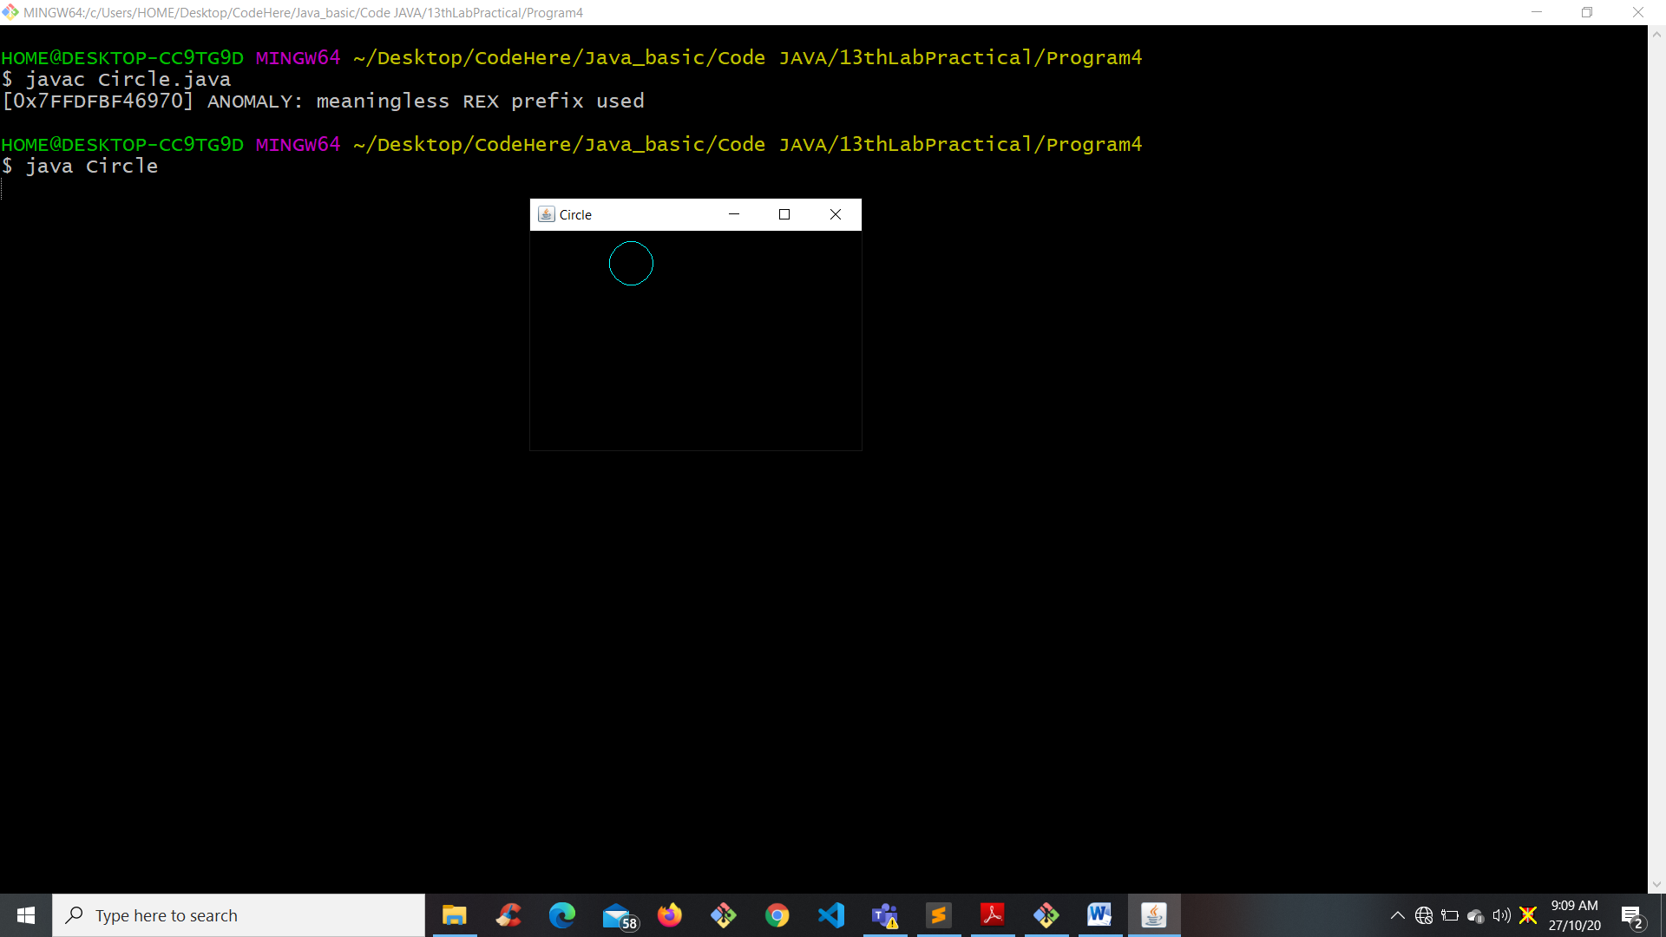

**Write a program to print ellipse in Frame with specification (x, y, width, height) = (200, 150, 50, 25) .**

import java.awt.*;

import java.applet.*;

import java.awt.event.*;

public class Ellipse extends Frame{

Ellipse(){

setBackground(Color.black);

setForeground(Color.cyan);

addWindowListener(new WindowAdapter(){

public void windowClosing(WindowEvent we){

System.exit(0);

}

});

}

public void paint(Graphics g){

g.drawOval(200, 150, 50, 25);

}

public static void main(String arg[]){

Ellipse obj = new Ellipse();

obj.setTitle("Ellipse");

obj.setSize(400, 300);

obj.setVisible(true);

}

}

Output:

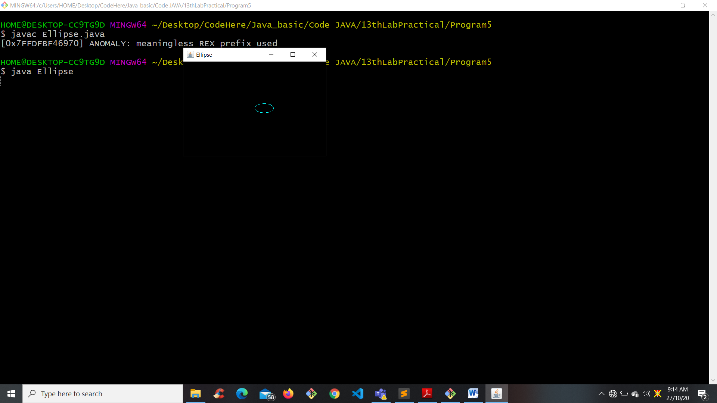

**Write a program to draw an arc from 4 o’clock to 8 o’clock in frame.**

import java.awt.*;

import java.applet.*;

import java.awt.event.*;

public class Arc extends Frame{

Arc(){

setBackground(Color.black);

setForeground(Color.cyan);

addWindowListener(new WindowAdapter(){

public void windowClosing(WindowEvent we){

System.exit(0);

}

});

}

public void paint(Graphics g){

g.drawString("Anti-Clockwise", 30, 80);

g.drawArc(40, 100, 150, 150, 330, 240);

g.drawRect(20, 60, 200, 170);

g.drawString("Anti-Clockwise", 250, 80);

g.drawArc(270, 100, 150, 100, 330, -120);

g.drawRect(240, 60, 200, 170);

}

public static void main(String arg[]){

Arc obj = new Arc();

obj.setTitle("Arc");

obj.setSize(500, 400);

obj.setVisible(true);

}

}

Output:

